

Ethical Review Form Postgraduate Educational Research Projects

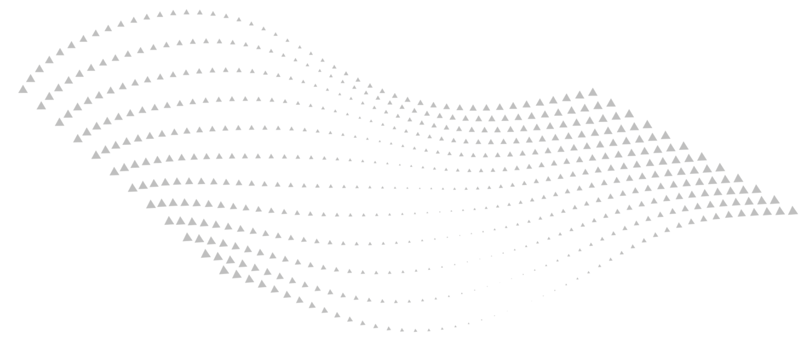

Last approved: | 2025
Approved by: | REC
Next review due: | 2029

Postgraduate Ethical Review Form for Educational Research

All primary research at BIMM University involving human participants requires ethical review. The purpose of this form is to indicate how you will be addressing ethical concerns in your research. Typically you should explain how you will gain informed consent from your participants, and how you will treat the data that result from conducting your project.
If your research is taking place within BIMM University, your module leader or supervisor can grant ethical approval on behalf of the institution based on the information in this form, and you should liaise with them for guidance as to how to complete the form and where to submit it. If they deem the project to be high risk they will pass the form to BIMM University’s Ethical Approval Committee for their judgement.
If you are conducting research elsewhere you will also need to explain here how you will gain approval from relevant stakeholders.

- Project title

2. Applicant details

Name of researcher:
Email address:
Your role (e.g. Masters student, freelance lecturer etc):
Location (your home Campus):

Please state which course you are on (PGCert or MALTCI):

3. Context for your project
[Where will you be conducting the research? Please give start and end date.]

- 4. Research type
[What type of research are you planning? e.g. action research, ethnography, narrative enquiry etc.]

5. Research aims
[What do you hope to achieve?]

6. Who will your participants be?
[Briefly describe who will be taking part, how many you plan to involve, and what role you expect them to play in the research.]

7. Briefly describe the research methods you plan to use
[For example, focus groups, research diary, observations etc. Please be as specific as you can. Include here all the methods that you might realistically use.]

8. Can you confirm that you will provide a Participant Information Sheet* (P.I.S.) for participants and relevant stakeholders to inform them about the research?
*Please use our standard P.I.S. for this (suitably amended).
[If you answered ‘no’ please explain why not; for example, your research may be personal to you and not involve others directly in any way.]

9. Can you confirm that you will obtain a signed Consent Form* when recording audio or video for your research involving participants?
*Please use our standard Consent Form for this (suitably amended).
[If you answered no please explain why not. Covert recording is almost always unacceptable so if you are considering this please consult your tutor or supervisor.]

10. How will you obtain appropriate consent* from your participants when recording is not involved?
*Verbal agreement, nods, show of hands etc in combination with a P.I.S. may be enough depending on the level of involvement – please discuss with your tutor or supervisor.

11. Will your research involve participants under the age of 18?
[If you answered yes, please explain how you will gain informed consent for under-18s to be involved; you should consult your tutor or supervisor for guidance on this.]

12. Are you conducting research outside BIMM University?
[If you answered yes, please explain how you will gain ethical approval from relevant stakeholders elsewhere; for example, this might involve discussion with a head of department or senior manager.]

13. How will you maintain confidentiality for your participants?

14. What possible risks to the safety and wellbeing of those involved can you identify, and how will you minimise these?
[For example, reputational risk for those involved, emotional distress in gathering data around sensitive topics, potentially vulnerable participants etc.]

- Please complete the following data management plan

Broadly speaking, research data falls into two categories:

- Personally Identifiable Data (Information sheets; consent forms; completed questionnaires, audio tapes, transcripts, etc);
- Anonymised Data.

These two different types of data require different management.

As far as possible, all research should be anonymized (names are replaced with codes, and all identifiable information such as locations, organisations and dates removed) or pseudonymized (using an alternative name, and disguising identifiable information such as locations, organisations and dates). Anonymisation is to be preferred, except where to do so would prevent the use of the data by third parties in the future in the event that the data is stored at the end of the project lifecycle. In this case, careful pseudonymization should be used.

The term ‘research data’ encompasses data in many different formats. This includes, but is not limited to: Text (PDF, doc, rtf, txt); Images (RAW, JPEG, PNG); Databases (Excel, Access); Multi-media, video and audio (QuickTime; mp3, mp4); Software; 3D and statistical models; Hard copies (logs, field notebooks, diaries, workshop notes, sketches, questionnaires); Correspondence (email, handwritten letters); Inputs and outputs of simulations and models.

Please complete the table below with as much detail as possible, listing all the data that you are planning to collect.

Please delete the examples provided in red below and replace with your own text.

Type of data | Format | Will this data be appropriately anonymised or pseudonymised?  (if “no” please provide a brief explanation why not) | How will this data be protected against accidental loss, damage, and unauthorised access? | Will this data be shared with others during the research project?  (If “yes” please explain how you will ensure that you maintain participant confidentiality).
Interview transcripts | Digital (Word documents) | Yes | Storage on personal laptop (password protected).  Regular backups will be made to a password-protected external hard drive. | No
Interview recordings | Digital (mp3 recordings on phone) | No (transcripts can be anonymised – original recordings cannot) | Backups will be stored on a password-protected hard drive. | No
Participant consent forms | Hard copy (paper forms) | No | Storage in a locked draw to which only I have the key. | No
Research diary | Hard copy | No | Storage in a locked draw to which only I have the key. | No

Are you planning to retain any research data? If so please explain how and why; otherwise detail your plans for the secure destruction of all data which will not be retained at the end of the project lifecycle:

15. Dissemination
[Do you intend to share data or research findings outside of BIMM University? If yes, please provide details e.g. a published academic article, conference paper.]

16. Reputation

[Could the project produce findings that may have a negative effect on the reputation of BIMM University? If yes, please provide details.]

17. Any other information that you feel is relevant here?

- Declaration

- The information on this form is accurate to the best of my knowledge and belief, and I take full responsibility for it.
- I understand that I am responsible for monitoring the research at all times and recording and reporting any unexpected events to BIMM University.
- If any serious adverse events arise in relation to the research, I understand that I am responsible for immediately stopping the research and alerting the relevant Course Leader at BIMM University within 24 hours of the occurrence.
- I am aware of my responsibility to be up to date with and comply with the requirements of the law and relevant guidelines relating to the security and confidentiality of personal data.
- I understand that research records/data which have been retained may be subject to inspection for audit purposes if required in future.
- I understand that I may not commence this research until I have been notified that the project has approval.
- I understand my responsibilities as an academic researcher and will comply with the British Educational Research Association’s ethical guidelines.
- I confirm I have engaged with the ethical guidelines provided by my course tutors at BIMM University.

Signature of Researcher:

Date:

19. Approval

Name and job title:

Signature:

Date:

